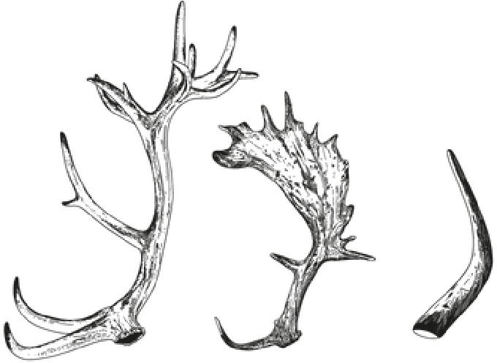
B r e a k f a s t
Knepp Apple Juice  Virgin Mary - Tomato juice & tabasco  Bloody Wilding Mary - Vodka, Tomato juice & tabasco  House granola  Yoghurt, Todoli citrus 2, 7, 10, 12  Turkish Egg’s  Herb yogurt, poached egg’s, Chili, mixed seeds &  Sourdough toast 2,4,7  Breakfast Bap  Knepp spiced sausage, Knepp bacon chilli jam, aioli, egg 2, 4,^{dgdgdgdd} 7, 14  Mushrooms on toast  Creamy mushrooms, poached eggs, Market Garden herbs 2,4,7  Add Bacon £3.50  Knepp Veggie Breakfast  Two poached eggs, Market Garden greens, mushrooms, baked beans, housemade hashbrown & sourdough toast 2,4,7,14  Knepp Wilding Breakfast  Knepp Breakfast sausage & bacon, baked beans, two poached eggs, housemade hashbrown & sourdough toast 2,4,7,14  Add-ons  Knepp bacon  Knepp Sausage  Housemade hashbrowns | 3.5 8  12  10  12  14  15  15  17  3.5  3.5 2
S e r v e d u n t i l 1 0 . 4 5 a m

1-CELERY 2-GLUTEN 3-CRUSTACEANS 4-EGG 5-FISH 6-LUPIN 7-DAIRY
8-MOLLUSCS 9-MUSTARD 10-NUTS 11-PEANUTS 12-SESAME 13-SOYA 14-SULPHITES
If you have any allergies or dietary requirements please speak to a member of staff who will be happy to help.
A 10% discretionary service charge will be added to your bill. 100% of tips go to our team. Card & contactless payments only — thank you for understanding.
Our drink list features organic wines, spirits, soft drinks, and hot drinks all sourced from small, trusted producers. Thoughtfully chosen, sustainably made.

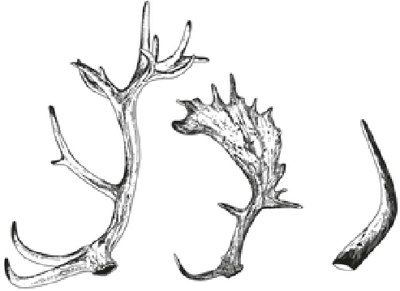
SOFT DRINKS
Still water 330ml/750ml  Sparkling water 330ml/750ml  Belvoir Ginger Beer  Belvoir Ginger Ale  Belvoir Sparkling Elderflower  Gusto Cola/Slim Cola  Gusto Sparkling Blood Orange  LemonAid - Passionfruit/Lime  Holos Citrus Hops Kombucha  ORGANIC COFFEE, TEA, & HOT CHOCOLATE  Espresso | 2.5/4.5  2.5/4.5  3.9  3.9  3.9  4.5  3.9  3.9  4.9
Flat White  Latte  Americano  Cappuccino  Macchiato  Cortado  Mocha  Hot Chocolate  Chai Latte  Loose Leaf Tea  english breakfast/earl grey/green & peach/rooibos/peppermint/chamomile/berry  Oat Milk 50ml/250ml Syrup  CAKES | 2.9  3.7  3.9  3.5  3.9  3.3  3.5  4.5  3.7  4.5  3.2  0.1/0.4  0.6
Portokolpopita - Greek orange filo pie  Torte Caprese - Chocolate & almond cake  Orange & cinnamon bun  Fresh-baked fruit scone with butter & jam | 5  5  5  6

If you have any allergies or dietary requirements please speak to a member of staff who will be happy to help.
A 10% discretionary service charge will be added to your bill. 100% of tips go to our team.
Card & contactless payments only — thank you for understanding.

